

PROJECT REPORT

**SUBJECT:** Psychology in Everyday Life

**CODE:** HUM1022

**TOPIC:** Impact of Climate Change on Psychological Behaviour

**FACULTY:** Navin Kumar

**SLOT:** G2

TEAM MEMBERS

|  |  |
| --- | --- |
| **Name** | **Register Number** |
| Ashwini Dwivedi | 17BEC0354 |
| Saumya M Tripathi | 17BEC0670 |
| Binay Sanghi | 17BEC0679 |
| Abhinav Kumar | 17BEC0764 |

# ABSTRACT

Climate change harms mental well-being in a number of ways. From trauma and stress following disasters, to relationship damage caused by separation and displacement, the psychological effects of climate change can be enduring. Of course, these effects are heightened for certain vulnerable populations, such as elderly and low-income people, as well as those on the frontlines of climate change.

A valuation for the mental effects of world-wide environmental change involves perceiving the multifaceted nature and multiple implications related with environmental change; arranging impacts inside other social, innovative, and natural advances; and perceiving middle people and arbitrators of impacts.

This article depicts three classes of psychological impacts: direct (e.g., intense or horrible impacts of outrageous climate occasions and a changed domain); in-direct (e.g., dangers to enthusiastic prosperity dependent on observation of effects and concern or vulnerability about future dangers); and psychosocial (e.g., ceaseless social and network impacts of warmth, dry season, relocations, and climate related clashes, and post disaster modification).

Responses incorporate giving mental mediations in the wake of intense effects and diminishing the vulnerabilities adding to their seriousness; advancing enthusiastic resiliency and strengthening with regards to roundabout effects; acting at frameworks and approach levels to address wide psychosocial impacts. The test of environmental change calls for expanded natural education, an extended moral duty, examinations concerning a scope of mental furthermore, social adjustments, and a distribution of assets and preparing to improve therapists' competency in addressing environmental change related effects.

# BACKGROUND OF THE PROBLEM

The potential effects of environmental change on human wellbeing and prosperity have gotten impressive consideration. Less consideration has been given to potential mental and social effects of worldwide environmental change and to factors that moderate and intervene those effects.

Albeit some limited as well as prompt outcomes, for example, injury or stress coming about because of progressively outrageous climate occasions, might be seen to result from environmental change, most psychosocial impacts are probably going to be continuous and combined, and the association with worldwide environmental change might be less clear in the brains of those influenced. This incorporate warmth related savagery, clashes over assets, dangers to psychological wellness and tension and hopelessness.

Moreover, atmosphere change is probably going to have lopsided effect on those of less financial benefit or social status, and in this manner, as other ecological issues, has social equity suggestions that request thought. Accessible research proposes that the psychosocial effects of environmental change are probably going to be directed by various individual and logical components that expansion or reduction the seriousness of the effect just as the impression of the effect. Mediators of effects may incorporate nearness to atmosphere related occasions and wellsprings of helplessness and flexibility.

A person's view of environmental change effects can be directed by social standards and by their natural personality. The effects of environmental change are additionally prone to be intervened by 78 different sorts of intellectual evaluations, for example, appraisals of individual hazard and attributions of duty, too media portrayals of wellbeing impacts. In spite of the extent of the issue, individual involvement in results of worldwide environmental change is uncommon in numerous districts of the world.

Environmental change doesn't bring out solid responses in certain people, while for others it is a sign of a "worldwide environmental emergency" causing vulnerability and enthusiastic pain. Despite the fact that responses to atmosphere change are interceded and directed by qualities, convictions, and experience, self-detailed feelings about environmental change are normal.

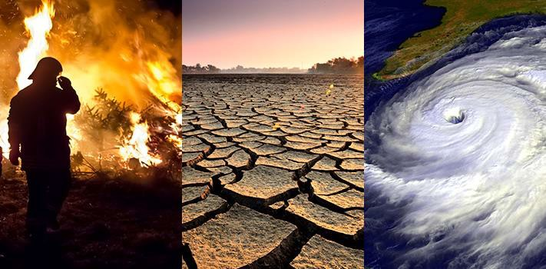

In the US, a lion's share of individuals state they are keen on an Earth- wide temperature boost; around half report feeling nauseated, confident, defenceless, or pitiful about the issue, and a quarter report feeling discouraged or remorseful. In any case, feelings are most elevated in bunches at the two parts of the bargains range. Those in the frightened gathering (18% of Americans) are significantly more liable to report being persuaded of the truth and peril of environmental change and to feel tragic, sickened, furious, or apprehensive.

Among the pretentious gathering (the individuals who are similarly persuaded that environmental change isn't happening and that no reaction ought to be made, 7% of Americans), the most grounded feelings were appall and outrage. Gatherings running from concerned, wary, withdrew, or far-fetched (33%, 19%, 12%, and 11% of Americans, separately) would in general report dynamically less experience of or passionate reaction to environmental change.

# DISCUSSION BEFORE CONDUCTING THE RESEARCH

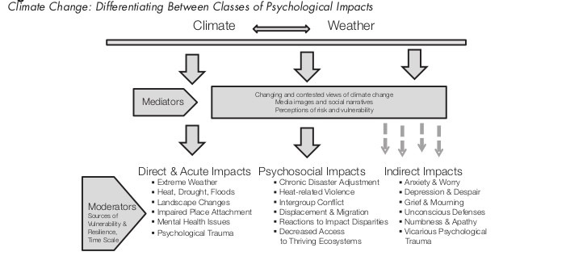

Before we begin the research, the common perception of the general public in matters of climate change on their psychology stays cold, not most of the people think it even as an issue to be even considered.

But in various encounters of people battling with their anxiety of harming the ecology is huge. It might be because they care about the environment very much, but in most cases it’s their personal story which is in some or the other way entangled with the harsh brutality of the effects of climate change and bio-warfares.

# TYPE OF RESEARCH METHODS USED

Survey [Google Forms]

# SIGNIFICANCE OF THE TOPIC

Much information bolsters the contention that present degrees of human utilization, in mix with developing populace, are having a huge negative effect on the common condition and are adding to environmental change. Proceeding the current pace of emanations is relied upon to yield an incredible assortment of unfortunate results, expanding after some time.

Holding per capita emanations steady, populace increments expected in the following 50 years would expand the worldwide emanations rate by about half. A much bigger increment would result if per capita outflows from vitality utilization in creating nations, 2.2 metric huge amounts of CO2 in 2005, expanded to the U.S. level of 19.5 metric tons. Brain research can help comprehend what drives populace development and utilization and explain the connections from populace and utilization to atmosphere change while taking care of worldwide and territorial imbalances.

Moral concerns. Various moral concerns rise while examining populace and utilization. As for populace, these incorporate worries about regenerative rights and decisions (what number of kids to have, regardless of whether to utilize contraceptives, and whether to have premature births), an unborn youngster's entitlement to life, and an old person's entitlement to kick the bucket. Besides, concerns are raised when answers for populace development target poor nations that are delivering few GHG discharges and when arrangements fuel against movement talk.

Different concerns encompassing populace development and circulation include the privileges of human and natural networks that are negatively influenced by the expanding size 51 what's more, spread of human populaces. Quandaries rise when these rights are confined as being in rivalry with one another. As to utilization levels, moral concerns emerge from inconsistent prosperity over the globe and inside areas of the world related with various degrees of vitality utilization.

Endeavours to check utilization, contingent upon how the decreases are disseminated, can keep up or intensify existing imbalances. Some low- pay nations and locales need, and some state ought to reserve the privilege to, grow monetarily in manners that depend on industry and that have continuously expanded outflows previously.

Mechanical arrangements that offer vitality's types of assistance without utilizing non-renewable energy source may keep up well-to-do ways of life and raise prosperity for destitute individuals, while all the while diminishing ozone harming substance emanations. In any case, mechanical arrangements are not without issues. Not all can bear the cost of the arrangements.

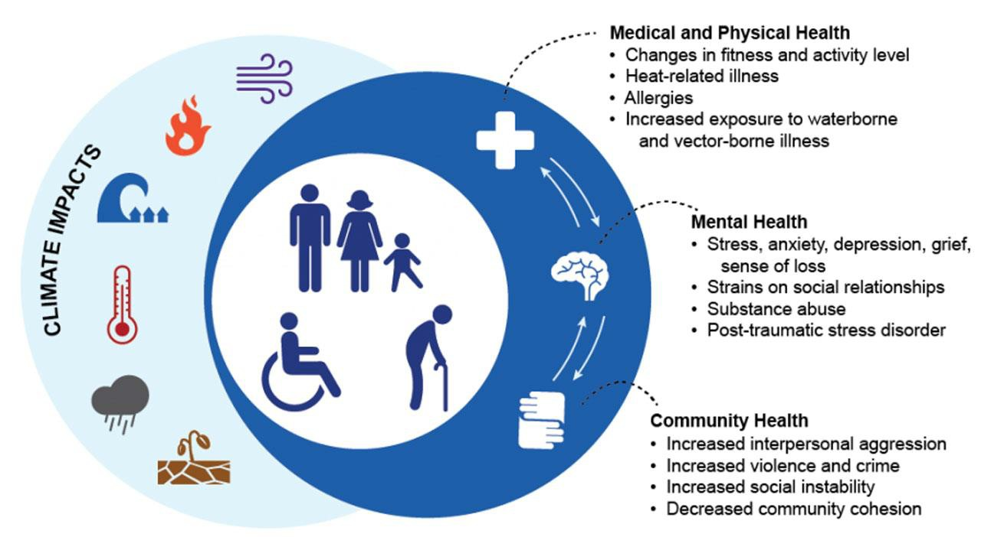

Regardless of whether individuals can bear mechanical arrangements, these arrangements, while diminishing GHG discharges can in any case adversely sway the earth legitimately in different manners, for instance, from the procedures and ecological effects required to make the arrangements, or by implication by empowering human living spaces to infringe upon regular natural surroundings.

The advantages may likewise be balanced by increments in populace or financial movement. The nearness of such issues makes it progressively basic to see how individuals settle on choices that impact environmental change through their practices and their help for strategies impacting populace and utilization, and to inspect the qualities fundamental conduct and arrangement support. Expanding populace size and utilization speak to classes of practices that clarify the manners in which that human conduct adds to environmental change.

These classes of practices are installed in bigger settings that impact them. So as to comprehend and address the connections from populace and utilization to environmental change, it is valuable to comprehend mental, 52 social, and social drivers of populace and utilization and to comprehend what it is about populace and utilization that impacts environmental change.

Quite a bit of this exploration has been done outside of brain science, for instance, by demographers; we propose manners by which brain research could contribute more to this conversation. The connection among populace and environmental change streams through the aggregate effect of earth critical examples of utilization.

In this way, subsequent to examining populace development, we give a mental examination of utilization through a model that incorporates indicators and outcomes of ecological utilization. We at that point expand on the model by first disaggregating utilization practices into those that have direct (ecological utilization) and roundabout (financial utilization) sway on environmental change.

At that point we represent what brain research can add to understanding mental and social indicators of utilization while perceiving auxiliary, financial, and physical requirements on utilization choices. By giving instances of indicators of populace size and utilization and the methods by which populace and utilization impacts environmental change, we represent how brain research has and could promote our comprehension of human commitment to environmental change by means of populace and utilization.

# ALREADY KNOWN FACTS ABOUT THE TOPIC

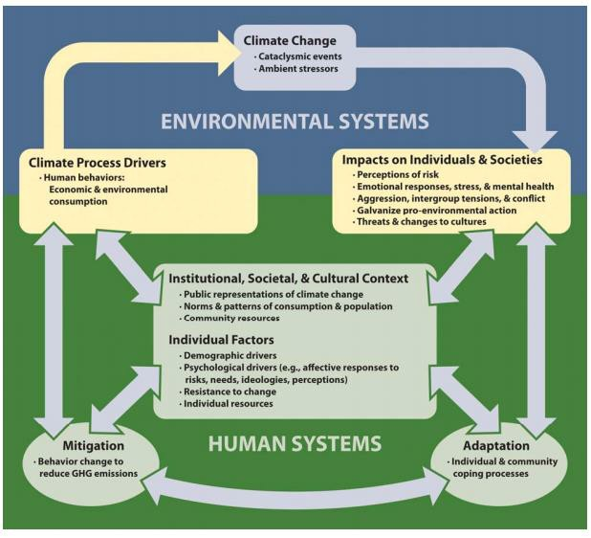

Numerous components can be recommended as potential middle people or arbitrators of reactions to environmental change. Specifically, the social setting, as started up in both vis-à-vis systems and in channels of mass correspondences, influences access to data, encircling of that data, and weakness in light of the data. Individual qualities will likewise influence the sum and kind of data that individuals search out and the manner by which they react to it. We feature a couple of the main considerations.

A feeling of effect or alert in regards to environmental change is probably going to be both intervened by intellectual evaluations, for example, appraisals of individual hazard and attributions of obligation, and directed by the reactions of one's social referents.

For instance, in the US, a few gatherings see current peril and damage, while different gatherings see that society will have the option to adjust to any antagonistic impacts of environmental change once they show up.

Albeit both frightened and contemptuous gatherings will in general be profoundly taught, they vary on liberal versus traditionalist political direction, philanthropic versus individualistic qualities, and mentalities toward natural insurance versus financial development.

Catastrophes likewise will in general include particular stages and developing examples of effects extending from the intense to the ceaseless. Albeit human blunder and absence of readiness may add to the seriousness of calamity impacts, mechanical fiascos, given their human causes, are noted for a formative grouping that incorporates brooding and admonishing stages just as a post recuperation period concentrating on request, arrangement of social equity, and authorization of social and authoritative changes.

The roundabout, vicarious effects of worldwide environmental change incorporate passionate and full of feeling reactions related with review pictures of natural debasement or human enduring in the media or with inquiries of way of life or buying decisions.

Analysts can approve the range and degree of these effects, move strong intercessions, and portray the connections between these passionate reactions and practices related with environmental change.

For instance, ongoing interdisciplinary conversations have perceived how passionate reactions to environmental change, thoughts of obligation and viability, and related adjustment procedures can be comprehended as entwined parts of a mental reaction to environmental change dangers. These procedures, thusly, intercede the degree of individual and aggregate commitment in ecologically huge practices.

# LIMITATIONS AFFECTING OUR RESEARCH

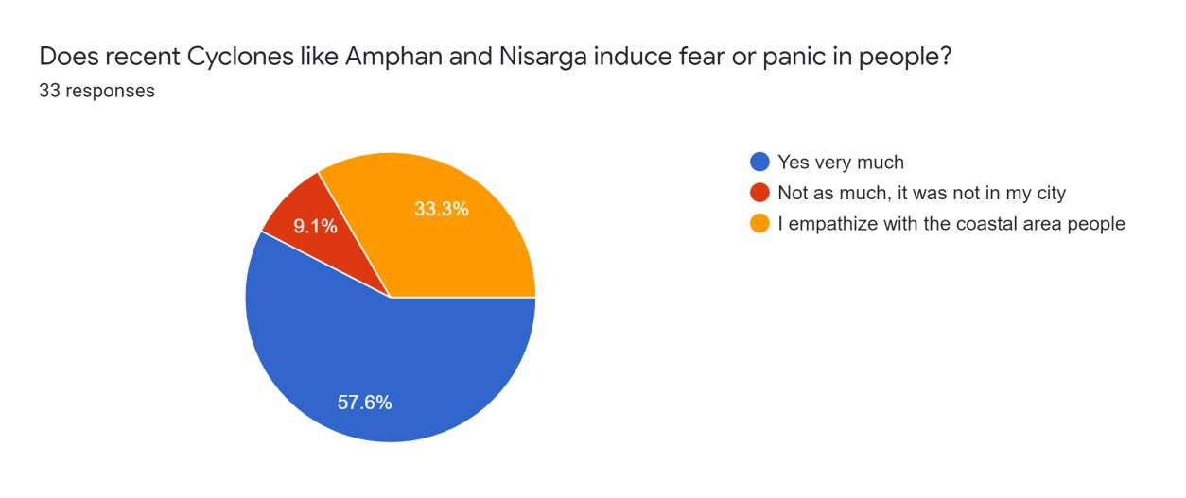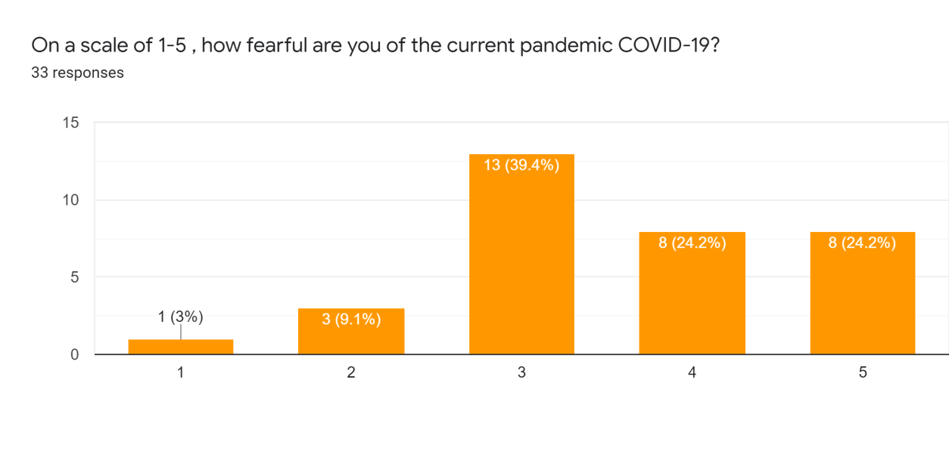

1. The survey done was an online survey, so we could not have “the human factor” in our surveys, talking to them face to face.
2. There is a possibility of randomized error, that is it might be that people choosing to attend the survey are biased or may be influenced by similar belief systems.

# RESULTS OBTAINED

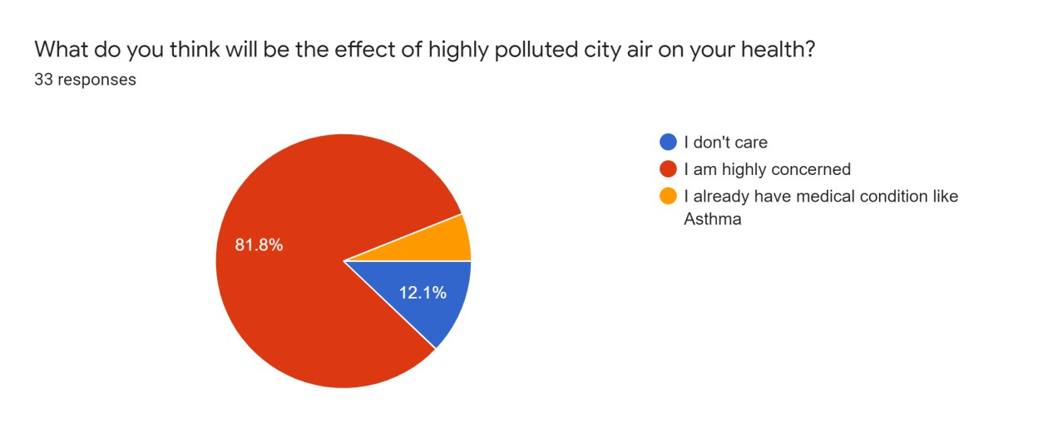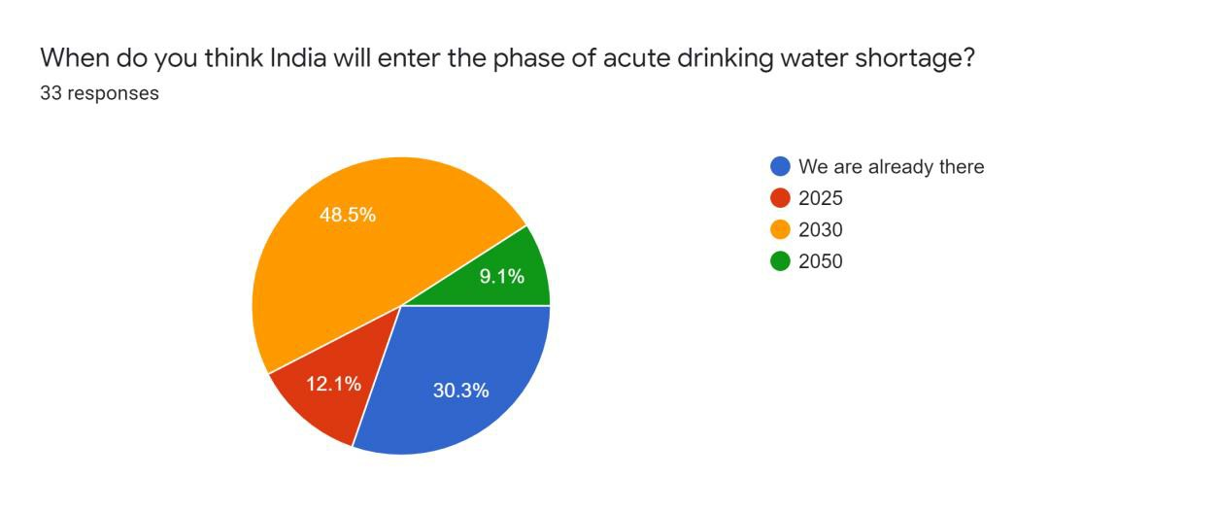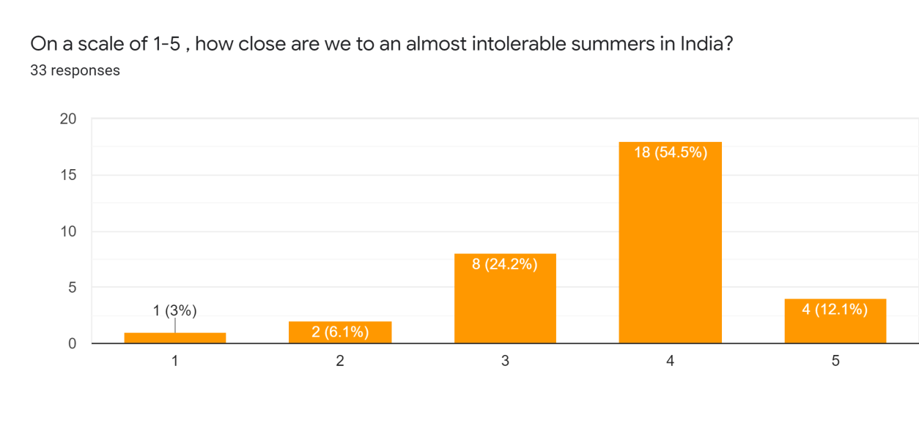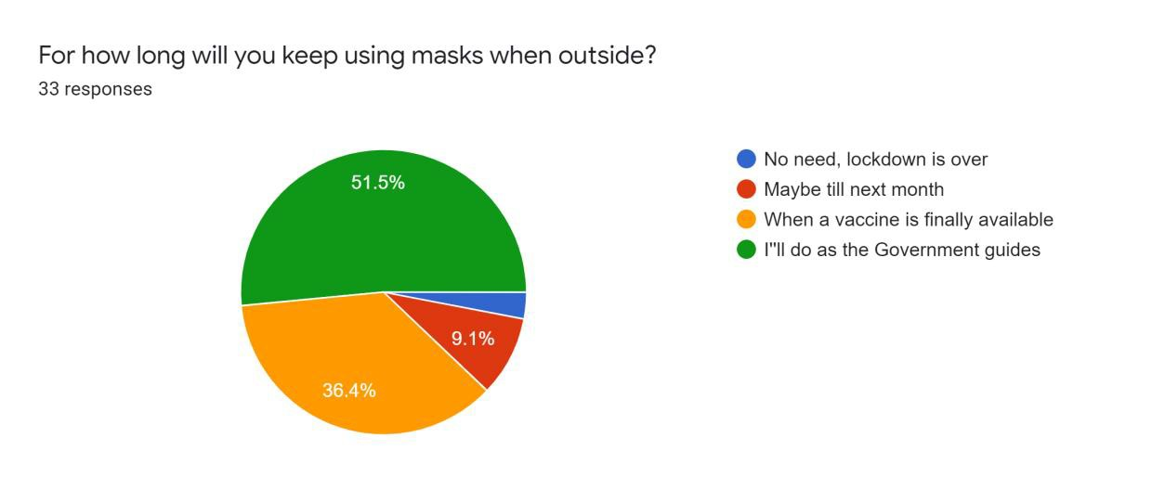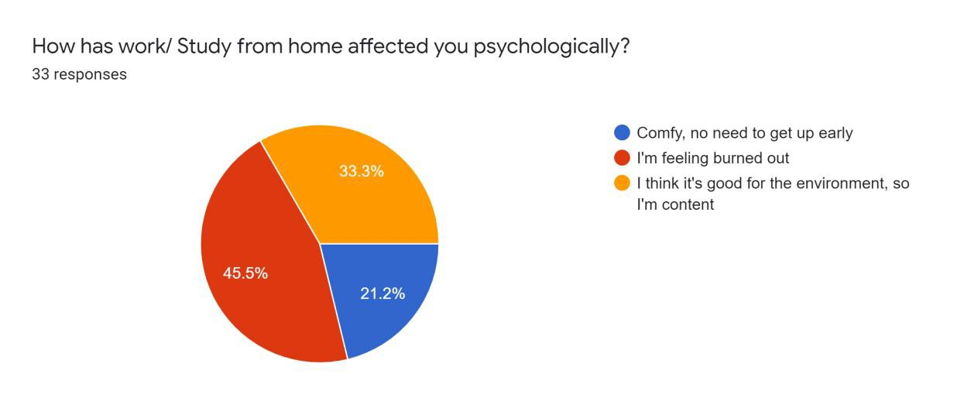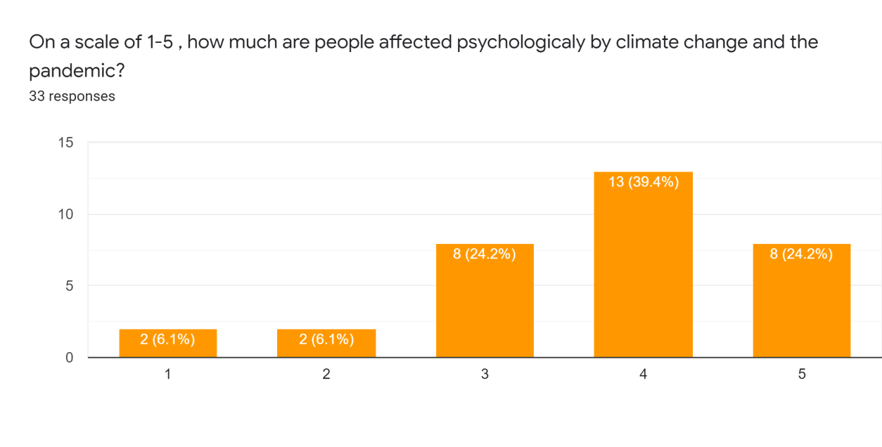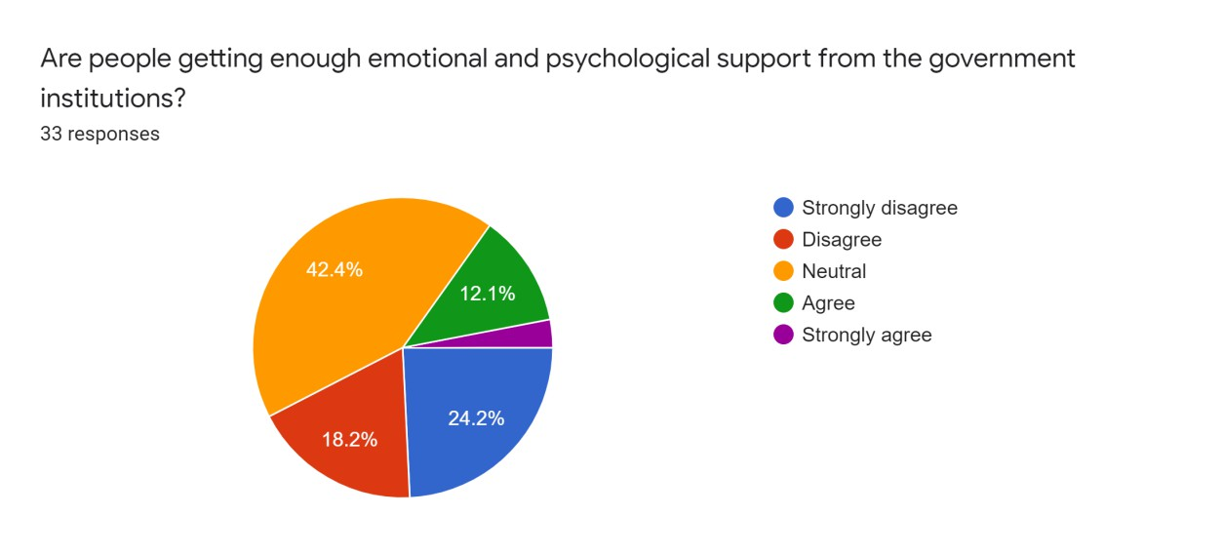

RESEARCH FEASIBILITY AND POSSIBLE AUDIENCES

The area our research covers is very personal opinion of the people taking the survey and how they perceive and interpret the climate change scenario and also how they plan to encounter it in their own way.

Our possible audiences are the people who are very much affected emotionally by Climate change and also a younger generation who needs to understand the gravity of the situation of not only the environmental effects but also the psychological impact of Climate change.

# RELEVANCE OF THE RESEARCH

It is required in a tough time the current COVID pandemic that we realise the psychological factors the humans face during quarantine and lockdowns; thus, this research similarly projects the thought human being on how they feel the upcoming crisis will affect their thought processes.

The pressure and adapting writing have underlined singular adapting reactions. Intra-clairvoyant reactions to experienced or foreseen encountering incorporate, for example, disavowal, ecological deadness, or 115 intellectual reappraisals, as well as feeling guideline.

Other individual reactions are conduct, for example, looking for data, looking for social support or participating in critical thinking by changing one's living space to acclimate to atmosphere changes, or then again captivating in relief.

Conversely investigate on ecological stressors and cataclysmic events has been bound to incorporate network level reactions. Network reactions to stressors incorporate, for example, volunteerism and making a difference neighbours adapt to absence of water or decimation of one's home.

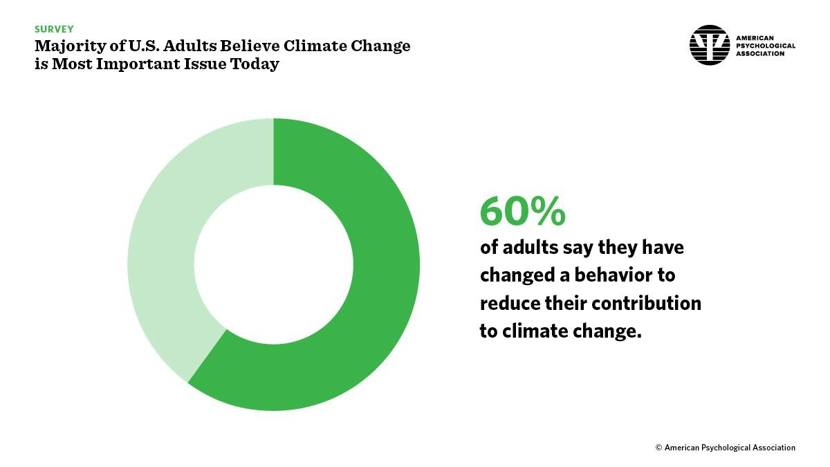

It isn't phenomenal for gatherings to develop after calamities that assist networks with adapting to emergencies. These people group reactions might be especially essential to consider when considering adapting to the effects of environmental change given the broadness and term of the effects.

While considering environmental change, extra explicit sorts of individual reactions that have not ordinarily been inspected in past research may should be tended to, for example, deserting social or good request, dependence on obdurate convictions, or dismissing customer driven ways of life.

# CONCLUSION

Thus, we conclude from above survey results that people are highly concerned about the climate change and how it will impact on their lives.



* Over 90% people think that Climate Change is real and is having an impact.
* Over 80% people think that highly polluted city is taking a toll on their health while 2% already have asthma like problems.
* Over 60% people think that natural calamities take a toll on peoples’ mental health also.
* Almost 90% people are thinking that the current pandemic is moderately or highly concerning.
* Almost 50% people think that acute water shortage will be there in India in as short time as 2030.
* Around 70% people think that summers have become already hostile in India.
* Around 36% people will be wearing masks till they get vaccinated.
* More than 45% feel already burned out of the lockdowns as it impacts their mental well-being.
* Around 65% people believe that climate change leads to psychological effects on humans.
* Around 26% people strongly disagree that government institutions are providing enough emotional and psychological support.

UNANSWERED QUESTIONS (FURTHER AREA OF THE RESEARCH)

* There is still an ocean of issues to be researched upon relating to how people respond and when will a revolution for amendments relating to psychological impacts due to environmental changes finally take place.
* Also, the matter that people might be being more affected in hot climates more as the time passes by due to global warming.

# REFERENCES

1. Allen J, Balfour R, Bell R, Marmot M (2014) Social determinants of mental health. *Int Rev Psychiatry* 26:392-407.
2. Berry HL, Waite TD, Dear KB, Capon AG, Murray V (2018) The case for systems thinking about climate change and mental health. *Nat Clim Change* 8:282-290.
3. Berry HL, Bowen K, Kjellstorm T (2010) Climate change and mental health: A causal pathways framework. *Int J Public Health* 55:123-132.